Game Design Document

Fill up the following document

1. Write the title of your project.

Flappy Bird

1. What is the goal of the game?

The goal is …the bird has to overcome all the obstacle she faces

1. Write a brief story of your game.

My game’s story involves a bird who has to overcome the all the obstacles and continue moving in her world

1. Which are the playing characters of this game?

* Playing characters are the ones who respond to the user based on the input from the user.
* Cars, monkeys, dinos, wizards, etc., are the playing characters in the game.

|  |  |  |
| --- | --- | --- |
| Number | Character Name | What can this character do? |
| 1 | bird | It can fly according to user’s will |
| 2 |  |  |
| 3 |  |  |
| 4 |  |  |
| 5 |  |  |
| 6 |  |  |
| 7 |  |  |
| 8 |  |  |

1. Which are the Non-Playing Characters of this game?

* Non-Playing characters are the ones that don't have an action or behavior when the user interacts with the game.
* Hurdles, stones, bananas, coins, etc., are non-playing characters in the game.

|  |  |  |
| --- | --- | --- |
| Number | Character Name | What can this character do? |
| 1 | pipes | It is an obstacle |
| 2 | background | It will act an an background |
| 3 |  |  |
| 4 |  |  |
| 5 |  |  |
| 6 |  |  |
| 7 |  |  |
| 8 |  |  |

Draw your imagination of this game. What does this game look like?

* Draw the game either on your computer or on paper.
* Add images of the game scenes to show each of the playing and non-playing characters at least once.

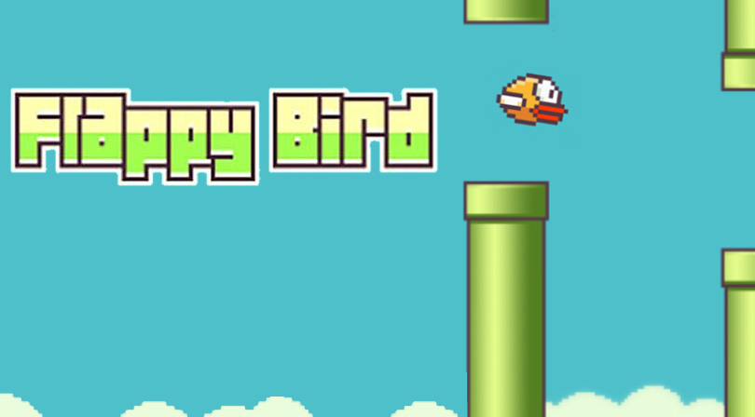

How do you plan to make your game engaging?

I have planned to give velocity to the bird and the controlling of the bird will be given to the user

And if the bird hit the pipes the game will end .